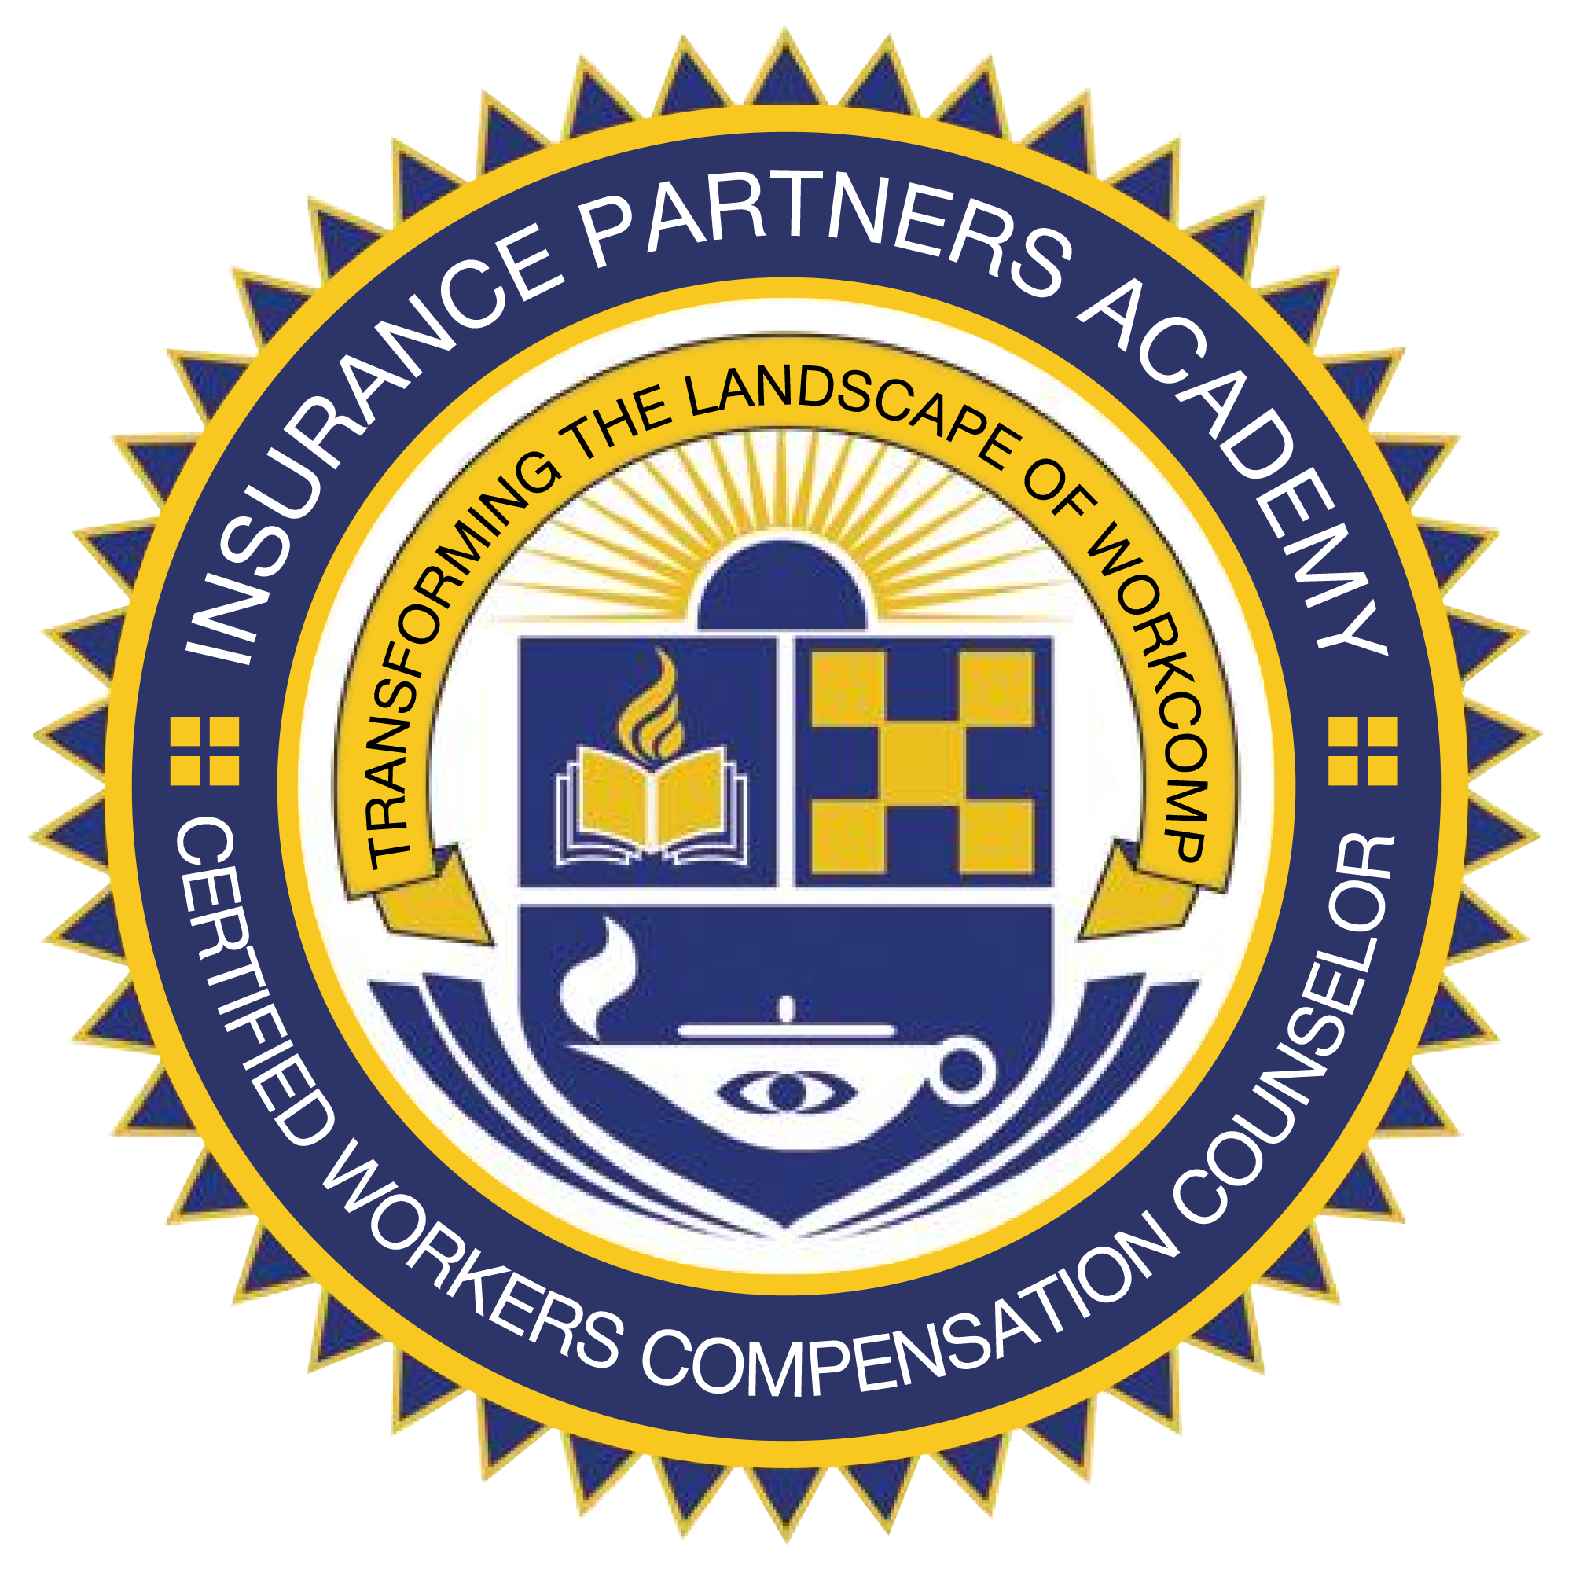

"Transforming the Landscape of Workers Compensation"
Certified Workers Compensation
Counselor Program (CWCC)

1/22/2024 – 1/24/2024

When: 1/22/2024 – 1/24/2024

Where: Live Virtual (Group Internet Based)

Faculty: Expert in Workers Compensation Insurance, Law, Occupational Disability Management and Claims Adjusting

Continuing Education Credits:
In process for webinar learning. Contact us for your specific state.

Cost: $595

To register:
www.insurancepartnersacademy.com or
amy.brown@insurancepartnersacademy.com

What People Are Saying
About Our Program

This is the most informative education class I have ever attended. This information is real and has practical use.
***
Excellent job; your class was awesome. I now consider you a part of my team/family. Your class was inspiring and loaded with content. I want to thank you for everything. I am already hard at work implementing all of your systems.
***
First class I have ever taken that I really felt was productive and pertinent throughout. I can’t thank you enough for the great time I had at the class. I also can’t stress enough how valuable it was. I felt smarter and better equipped to do my job. Added bonus to me is the operational advice. It will help me to apply my knowledge to the real world.
***
Great Class! Learned a ton of new things and answered questions that I had on subjects I knew something about…but not enough. I will definitely take what I learned and implement into my daily activities. This class has brought me to the next level. Thanks.
***
Best seminar I have attended. VERY practical. Exceeded my expectations.

Benefits of becoming a CWCC

- We give you an understanding of the work comp realities as well as the historical, social and moral issues surrounding workers compensation that will better equip you to assist your clients manage workers compensation total cost of risk.

- We will provide in depth claims handling fundamentals and best practices you can assist your client implement.

- You learn how to prepare your clients for successful audits.

- We teach experience modification basics as well as an advanced deep dive on analyzing and managing the experience modification.

- You will leave class with an excellent understanding of risk evaluation and program design including guaranteed cost, dividends, large and small deductibles, self-insurance, competitive state funds and the assigned risk/residual market.

- We help you understand the complex extraterritorial issues involving workers compensation from state to state.

- We show you how to identify and perform a variety of benchmarks and analyses to help you understand an employers’ claims performance.

- We teach you loss projections and trending and how to develop claims to ultimate pay-out.

- We walk you through the independent contractor and sub-contractor conundrum.

- We teach you the secrets to influence insurance pricing with underwriters that result in the most aggressive quotations for your business.

- We teach you how the classification code system works and discovering opportunities to acquire and retain accounts.



3099 Biddle Ave, Wyandotte, MI 48192

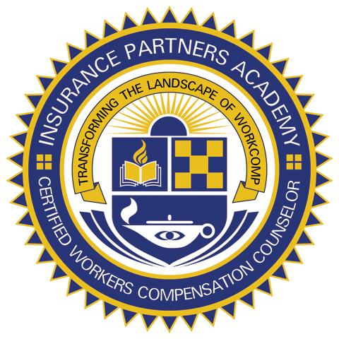

“Partnering People with Knowledge”

